Handling Unchecked Exception :

package com.java8;

import java.util.Arrays;
import java.util.List;

public class ClientTest {

public static void main(String[] args) {

List<Integer> integers = Arrays.asList(3,9,7,6,0,10,20);
try {
integers.forEach((i)->System.out.println(50/i));
}
catch(ArithmeticException e)
{
e.printStackTrace();
}

}

}

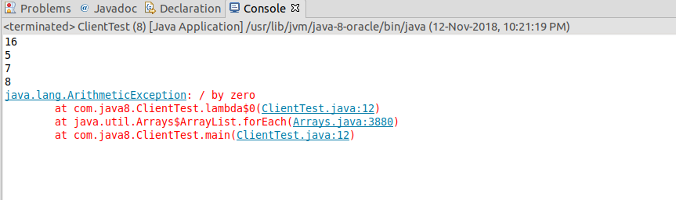

Now let’s implement try-catch block within lambda expression.

package com.java8;

import java.util.Arrays;
import java.util.List;

public class ClientTest {

public static void main(String[] args) {

List<Integer> integers = Arrays.asList(3,9,7,6,0,10,20);
integers.forEach((i)->{
try {
System.out.println(50/i);
}
catch(ArithmeticException e)
{
System.out.println(e.getMessage());
}});
}
}

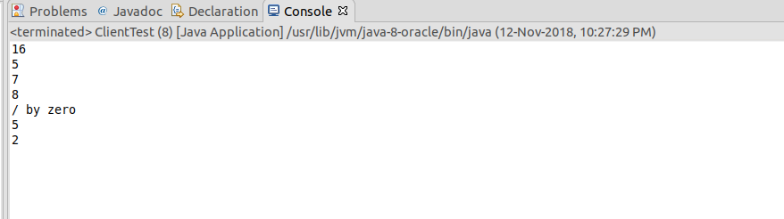

In this case, the consiness of Lambda Expression got lost.

Let’s implement it in different way.
Write one lambdaWrapper method whose return type and passing argument is Consumer<Integer> type where all the exceptions will be handled. And pass the lambda expression in that method from the main class which will be consumed.

package com.java8;

import java.util.Arrays;
import java.util.List;
import java.util.function.Consumer;

public class ClientTest {

public static void main(String[] args) {

List<Integer> integers = Arrays.asList(3,9,7,6,0,10,20);
integers.forEach(lambdaWrapper(i->System.out.println(50/i)));
}

private static Consumer<Integer> lambdaWrapper(Consumer<Integer> consumer)
{
return i-> {

try
{
consumer.accept(i);
}
catch(ArithmeticException e)
{
System.out.println("Arithmetic Exception Occurred : "+e.getMessage());
}
};
}
}

Check the video no 24.

